**Analysis of Exclusively Dark Images Dataset using OpenCV and Computer Vision**

**Project Description:**

The objective of the project is to improve dark images by applying computer vision algorithms. Enhancing the visibility and quality of underexposed or poorly lit photographs is the aim in order to make them more useful for a range of applications.

Scenario 1: Security and Surveillance

Low light levels often generate footage that is too dark to see crucial information in the security and surveillance industries, like person identification or suspicious activity detection. Through the use of cutting-edge computer vision techniques, this study seeks to improve such dark images. This project makes it easier for security professionals to monitor and effectively respond to any threats by enhancing the visibility of crucial characteristics in surveillance footage through the application of techniques like gamma correction and histogram equalisation.

Scenario 2: Medical Imaging

Underexposure may result in images from medical imaging tests like CT, MRI, and X-rays that are too dark to read clearly. The goal of this project is to create image enhancement techniques that will improve the clarity and brightness of these medical photographs. The project uses tools such as OpenCV to apply contrast modifications and other upgrades to show hidden features.

Scenario 3: Night - Time Photography

Poor lighting is a common problem for nighttime photographers, leading to dark underexposed pictures that lack clarity and detail. This study investigates how to improve such photographs by adding more colour and detail using computer vision algorithms. The project gives photographers the skills to recover lost details in nighttime photos using techniques like contrast stretching and brightness correction with OpenCV, transforming useless images into aesthetically pleasing and high-quality shots.

**Technical Architecture:**

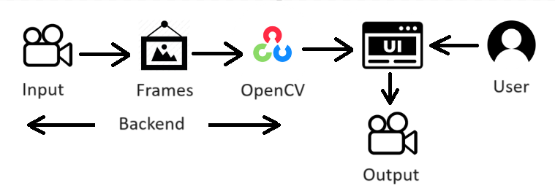

**Pre-requisites:**

To complete this project, you must require the following software, concepts, and packages.

1. **Python Packages**

If you are using **anaconda navigator**, follow the below steps to download the required packages:

Open the Anaconda prompt and create a virtual environment.

* Type “pip install opencv-python==4.9.0.80” and click enter.
* Type “pip install numpy ==1.26.3” and click enter
* Type “pip install flask” and click enter.

1. Proficiency in Machine Learning and Deep Learning models in Jupyter Notebook and Google Colaboratory.

**Prior Knowledge:**

You must have prior knowledge of the following topics to complete this project.

* Python
* OpenCV - <https://www.youtube.com/watch?v=WQeoO7MI0Bs>
* **Experience with Jupyter Notebooks & Google Colaboratory:** Familiarity with using Jupyter or Colab notebooks for coding, visualization, and documenting work.
* **Linear Algebra:** Understanding of matrices and operations on them, which are fundamental for image processing tasks.
* **Probability and Statistics:** Basic knowledge is useful for understanding image noise, filtering techniques, and statistical image enhancements.
* Basic Understanding of Image Processing Techniques

# **Project Objectives:**

By the end of this project you will:

* Know fundamental concepts and techniques used for computer vision.
* Gain knowledge of OpenCV.

**Project Flow:**

### **1. Project Planning and Setup**

* Define Project Scope
* Data Collection
* Environment Setup

### **2. Data Loading and Preliminary Inspection**

* Load Data
* Preliminary Data Inspection

### **3. Exploratory Data Analysis (EDA)**

* Statistical Analysis of Image Data
* Histogram Analysis
* Metadata Analysis (if applicable)
* Visual Inspection

### **4. Image Enhancement Techniques**

* Apply Basic Image Enhancement Techniques
* Visualise Results

**Milestone 1: Analysis Dark Images Dataset**

**Activity 1: Importing libraries amd mounting to drive**

* Import necessary modules ( numpy, pandas, matplotlib, cv2, os).
* Code snippet for importing these libraries and setting up the environment.

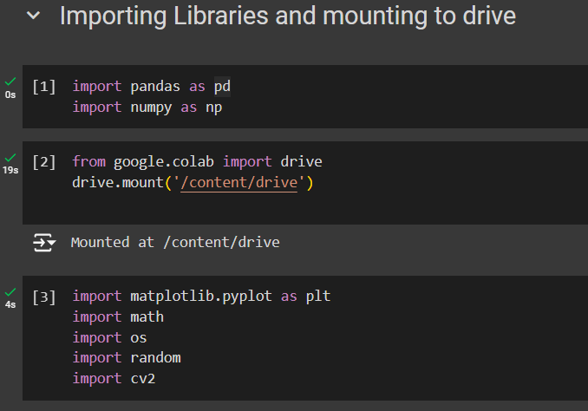

**Activity 2: Loading and displaying Extremely Dark Data**

* Load the entire Dataset via drive
* Copy the paths of all the dataset folders
* Explanation of how the data (dark images) was loaded from a directory.
* Visualisation of a subset of images using a custom function, visualize_images, to display a grid of sample images.

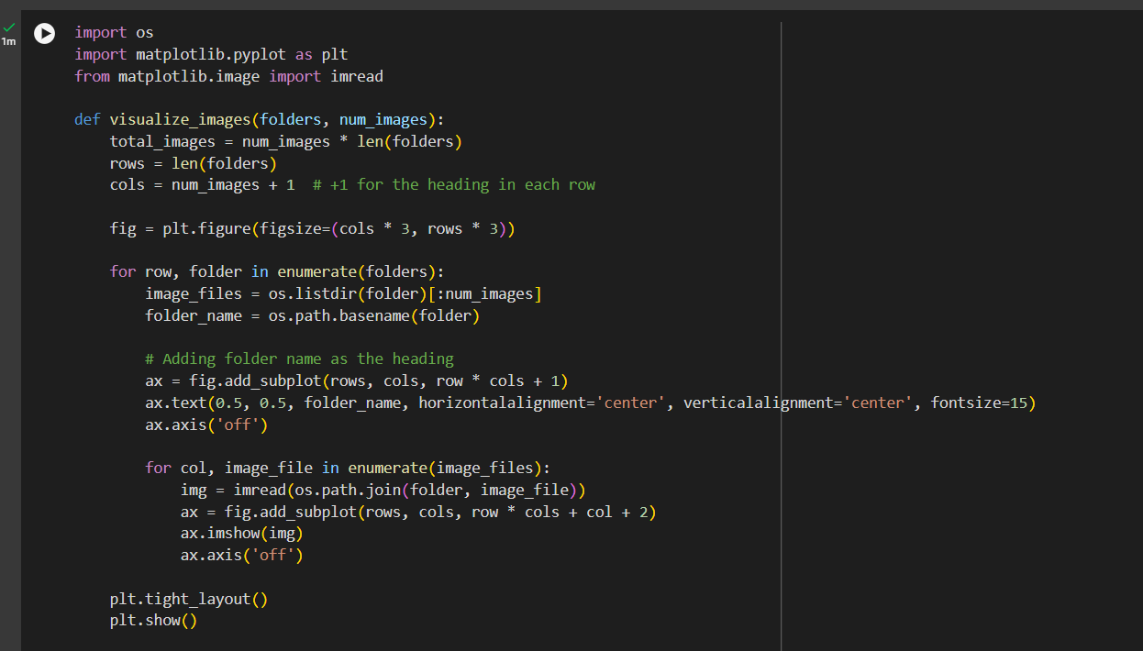

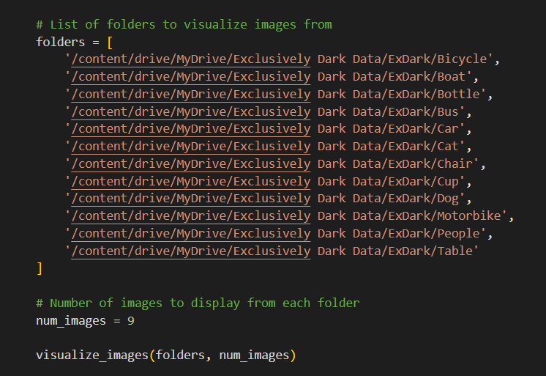

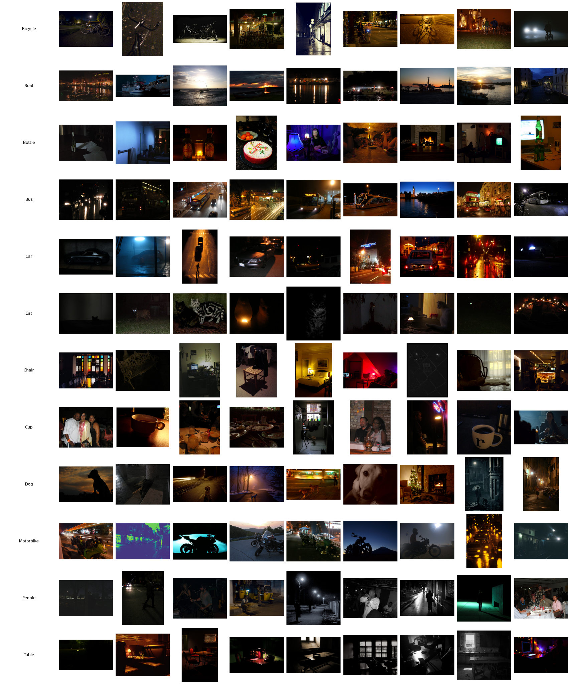

**Activity 3: Data Inspection**

* Define functions to count dark images in each folder.
* Preprocessing images and splitting the dataset into training and testing sets
* Checking the structure of the dataset
* Overview of inspecting the images to understand the extent of darkness and the types of images in the dataset.
* Key observations made during this step.

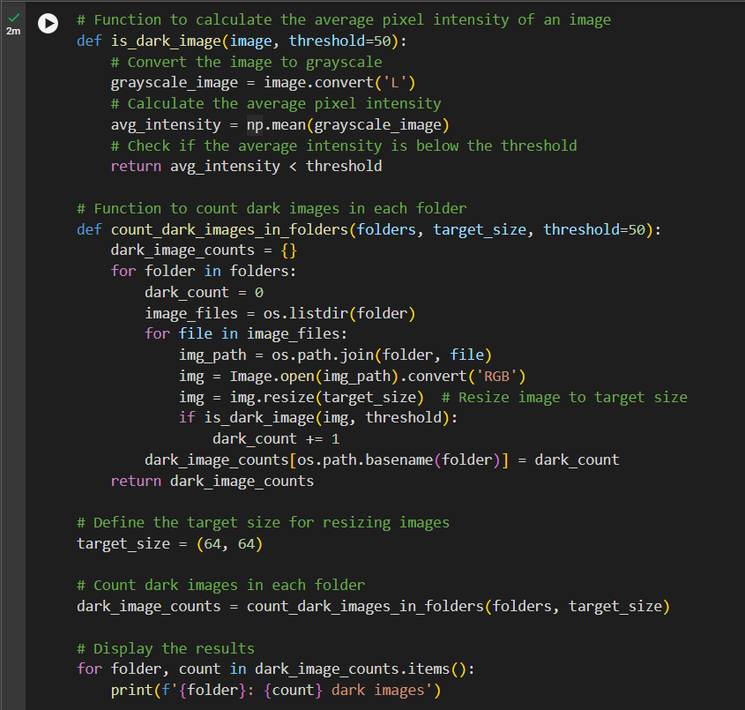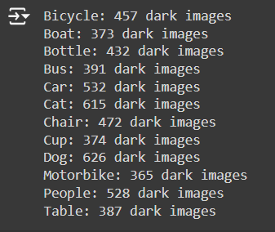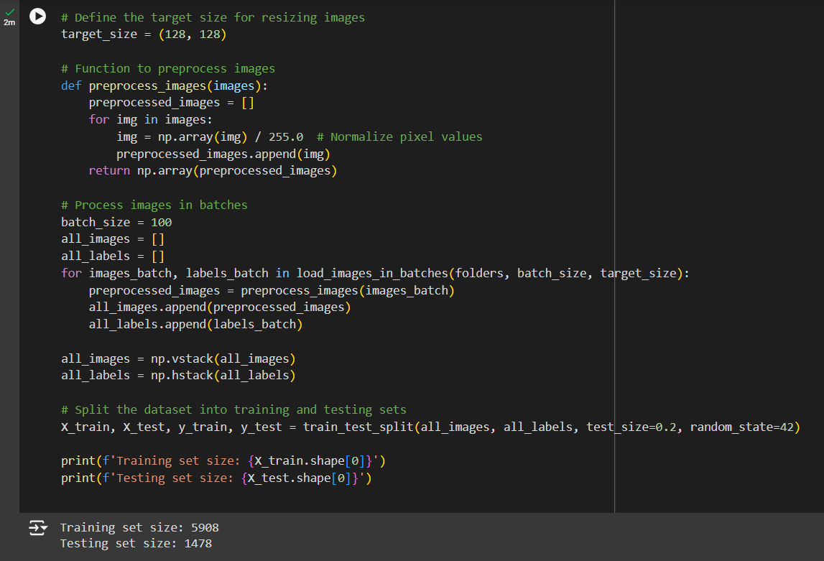

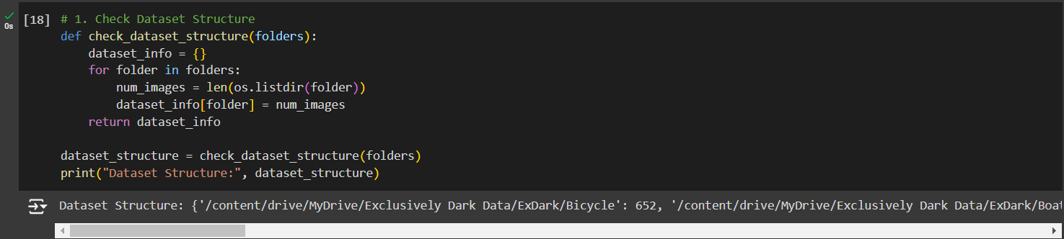

**Activity 4: Analysing data by basic visualisations**

* Plotting Distribution of images across categories.
* Checking if there are any missing or corrupted images.
* Checking the dimensions of each image of the dataset.

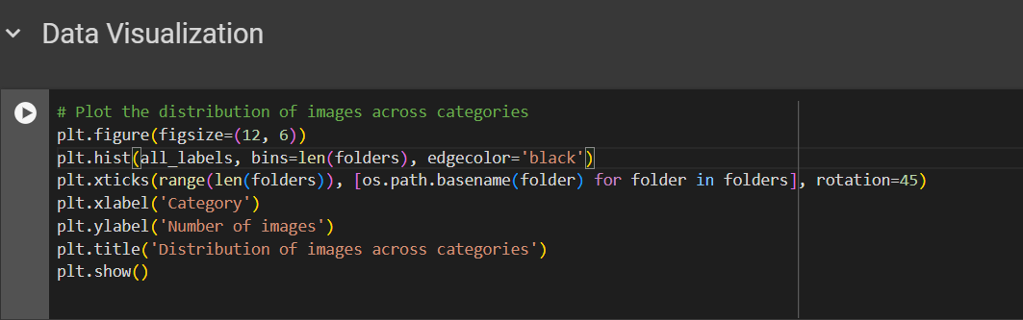

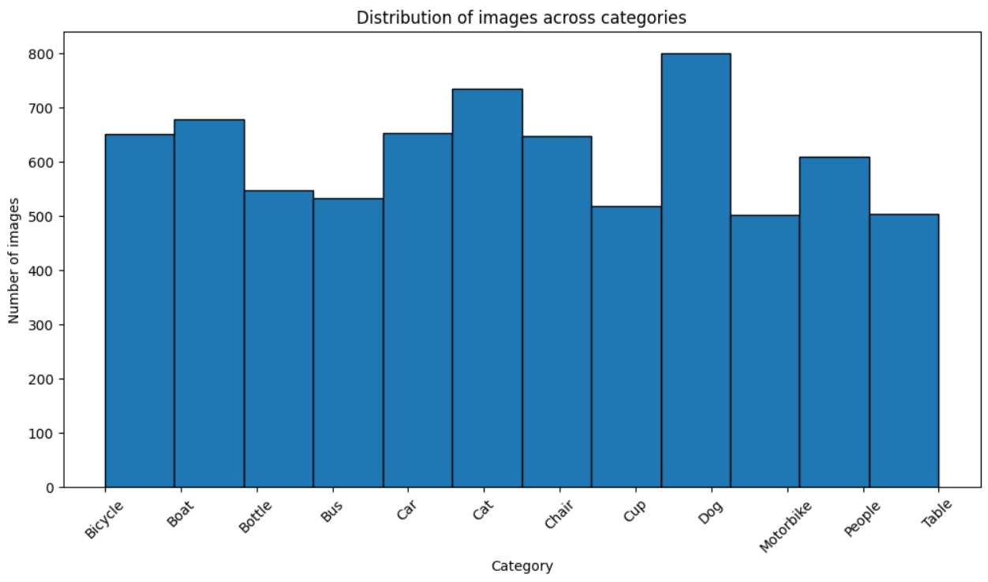

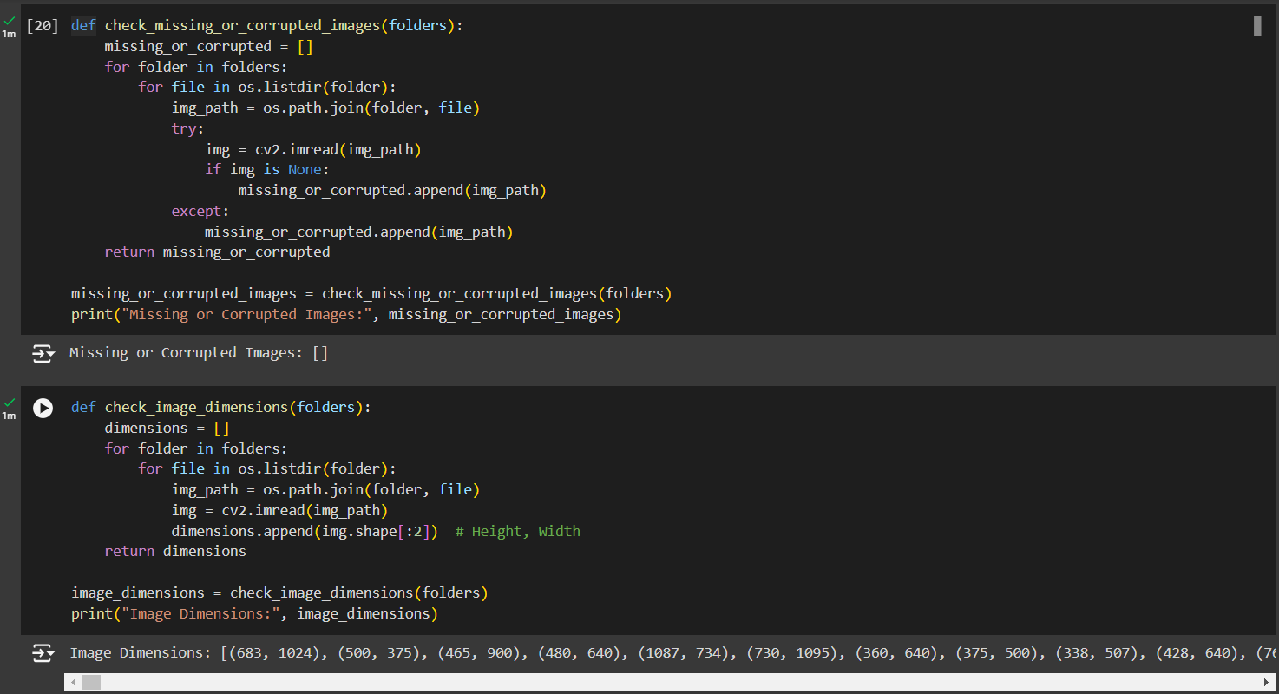

**Milestone 2: Exploratory Data Analysis and Computer Vision techniques**

Exploratory Data Analysis (EDA) is a crucial step in data-driven projects, particularly in computer vision. It helps identify patterns, spot anomalies, test hypotheses, and check assumptions. EDA helps in understanding image data characteristics before applying advanced processing techniques. It includes image size and aspect ratio distribution, color channel analysis, histogram analysis, data visualisation, and class distribution for assessing quality and identifying imbalances.

EDA in Computer Vision aids in data quality assessment, understanding variability, and feature engineering, identifying low-quality images, guiding preprocessing steps, and enhancing model performance.

**Activity 1: Exploratory Data Analysis**

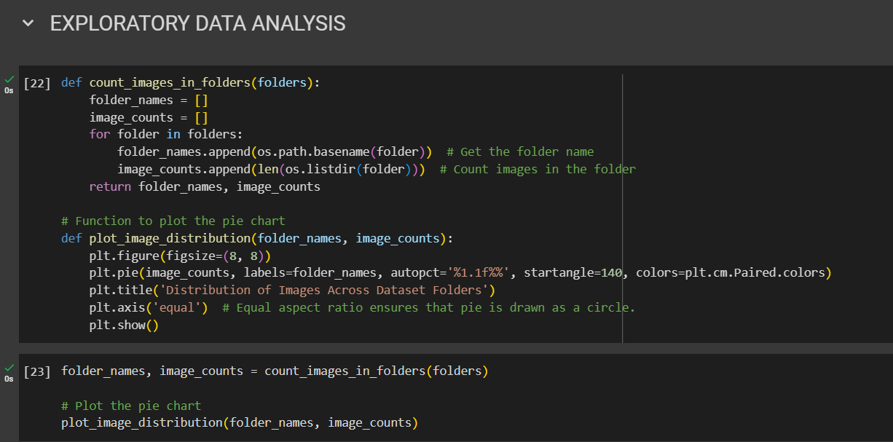

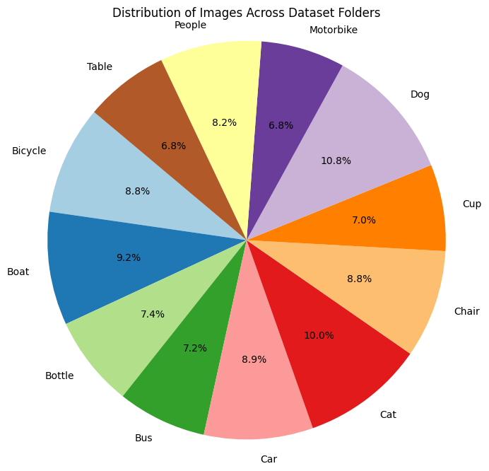

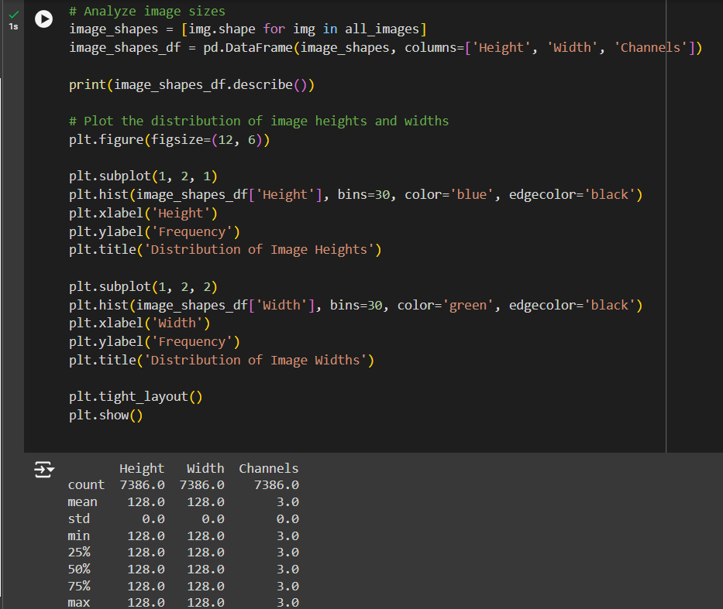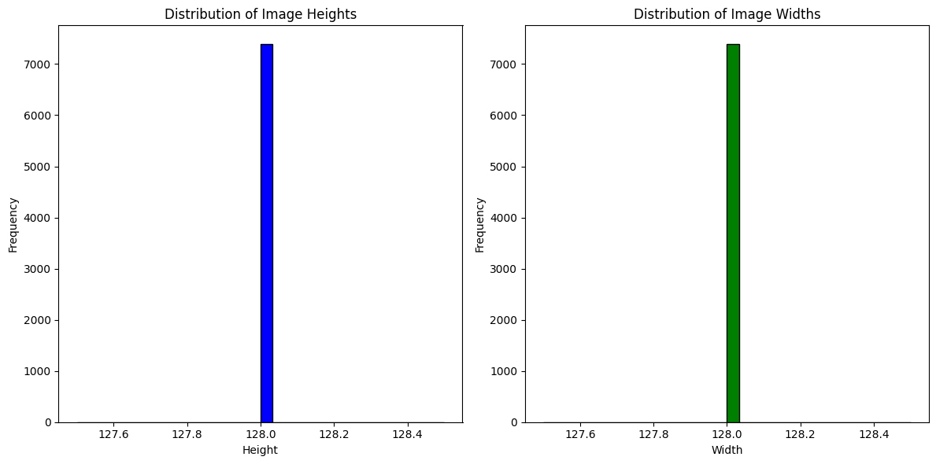

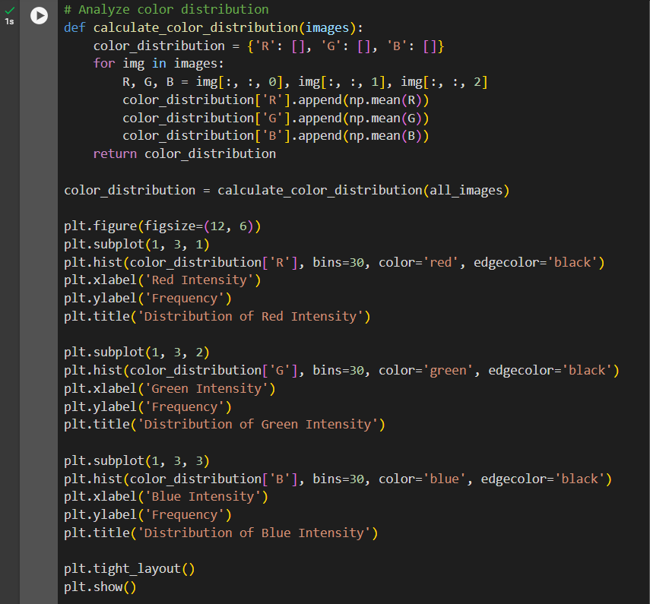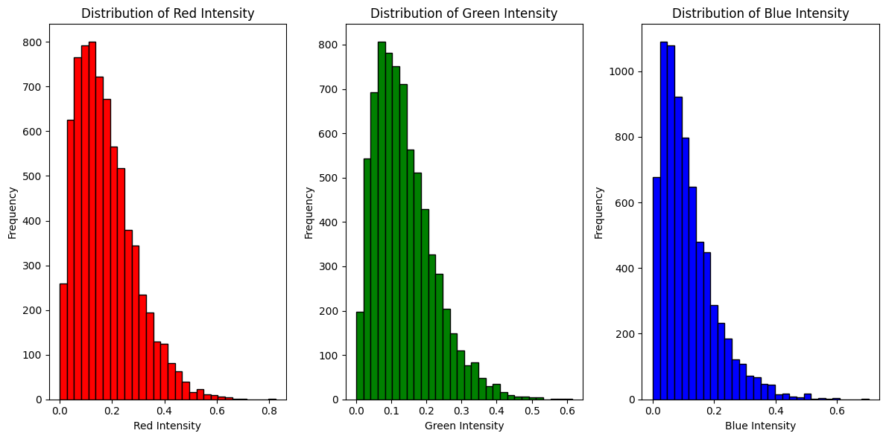

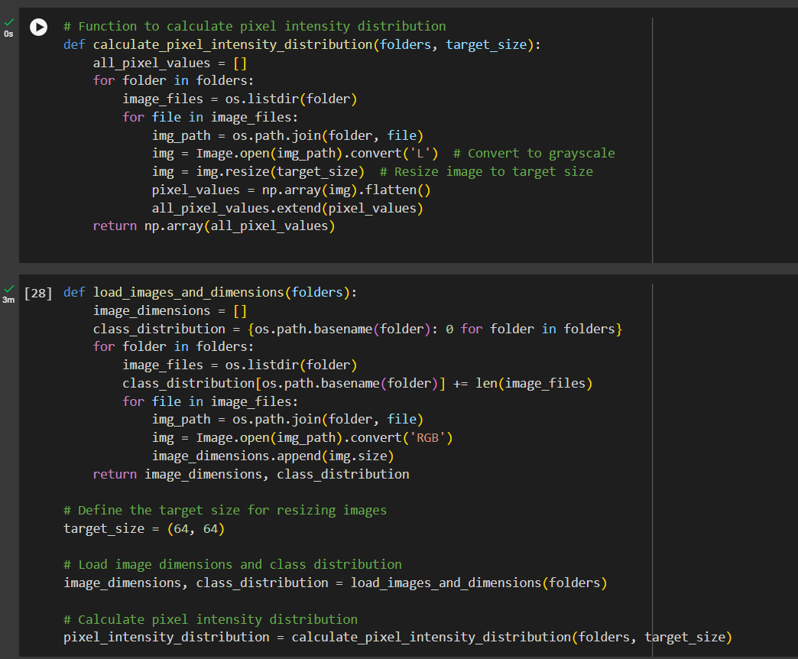

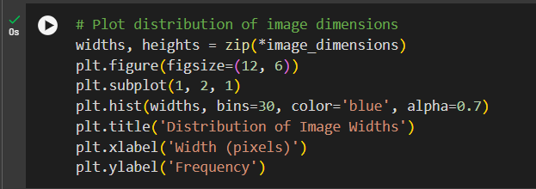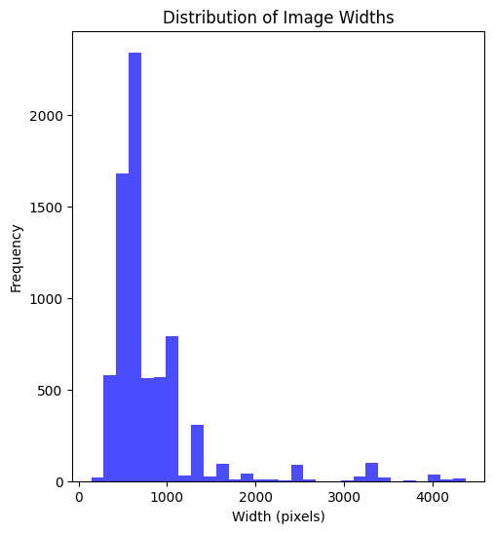

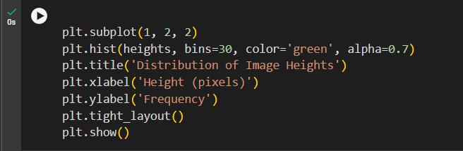

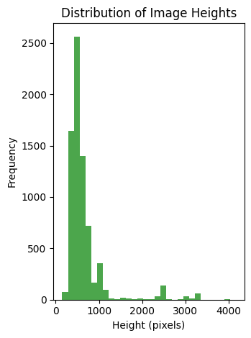

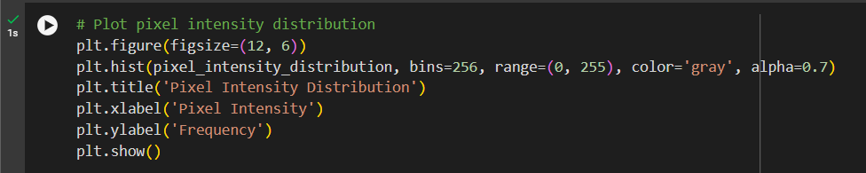

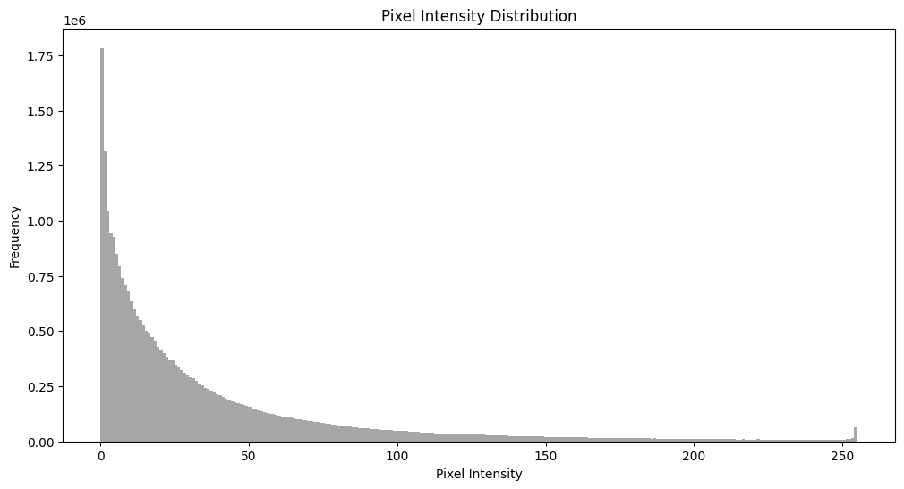

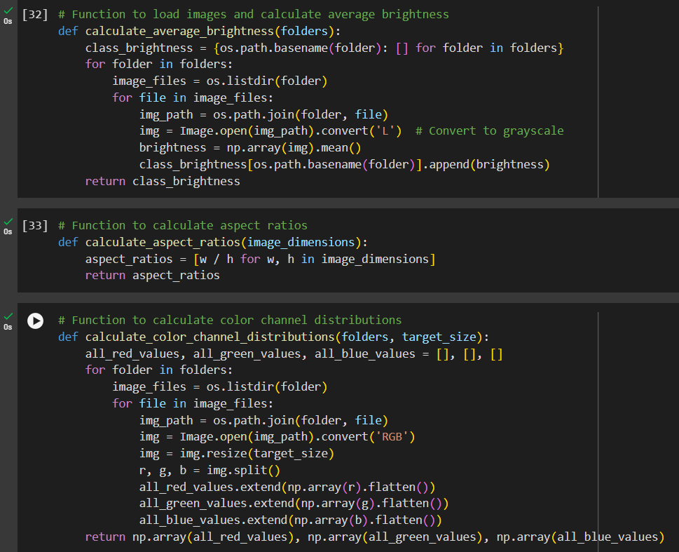

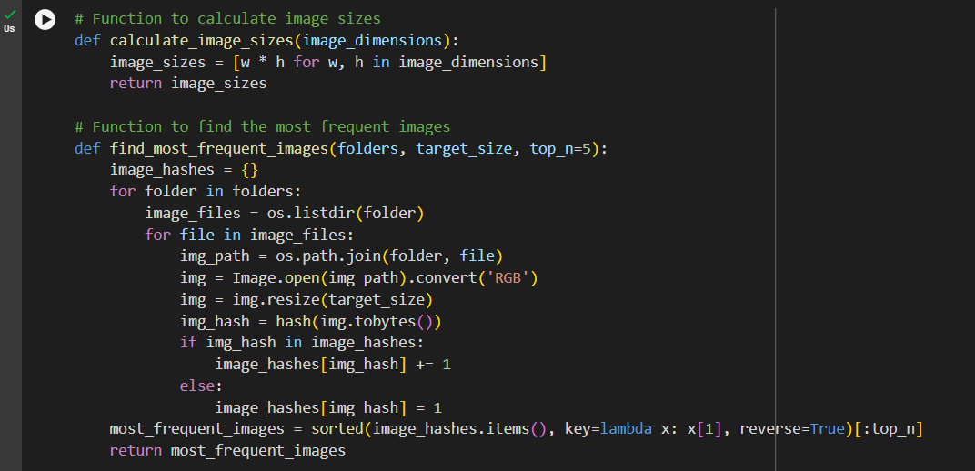

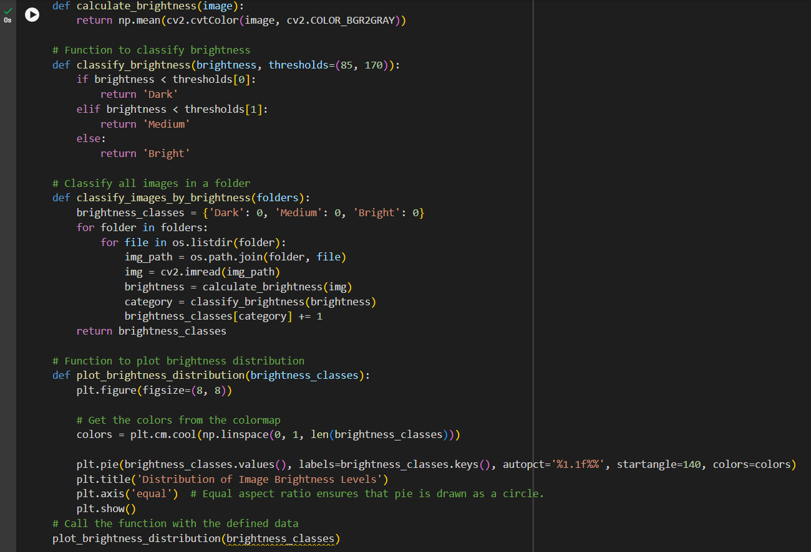

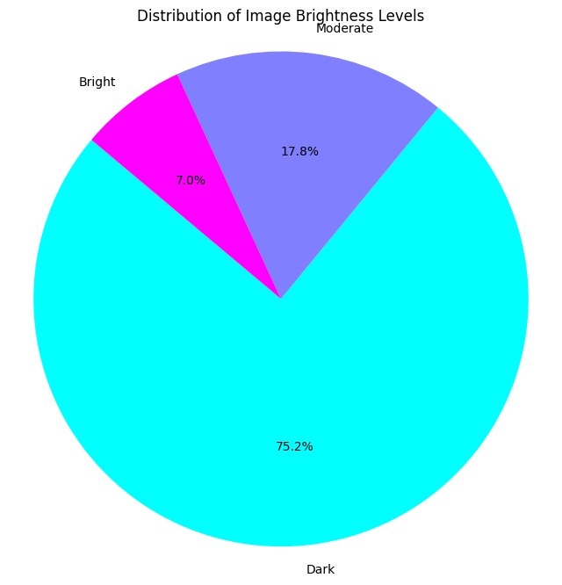

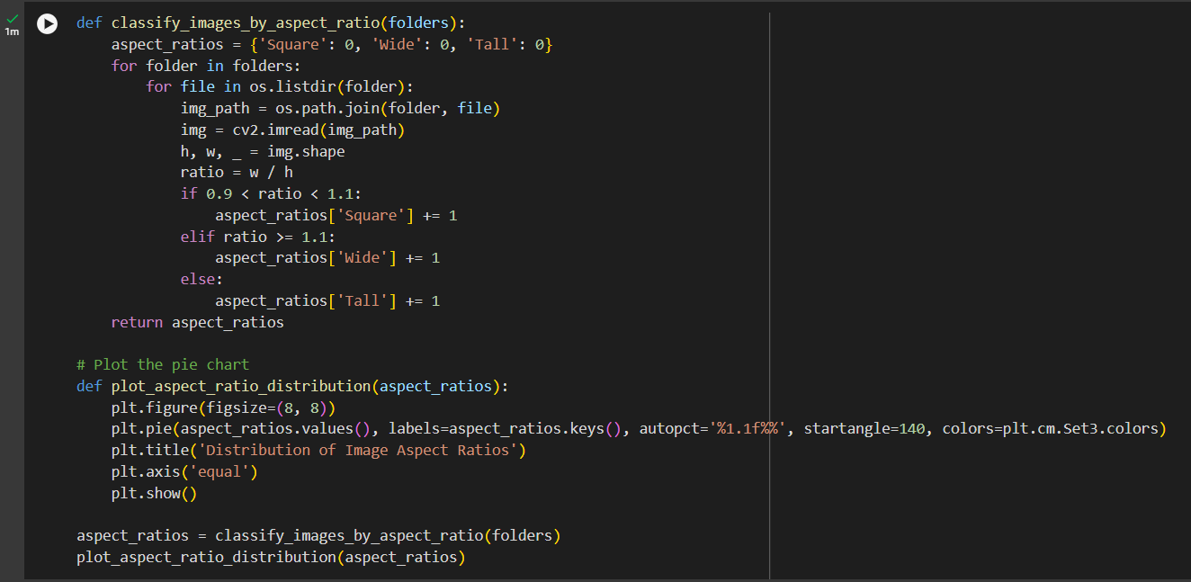

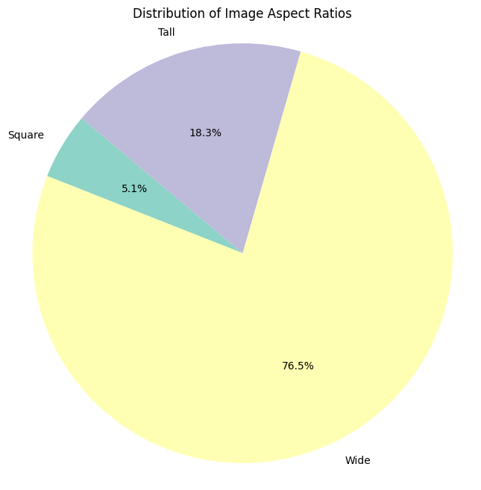

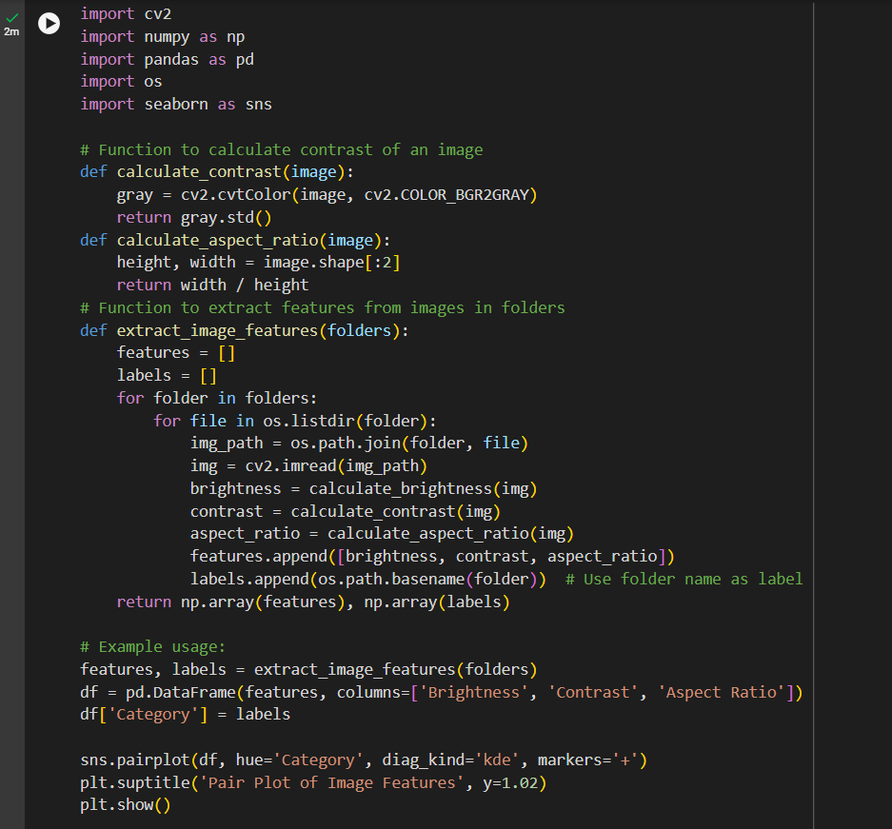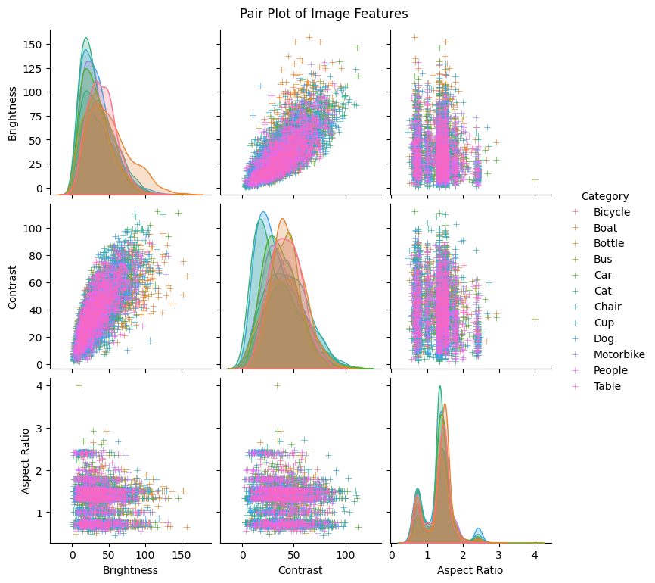

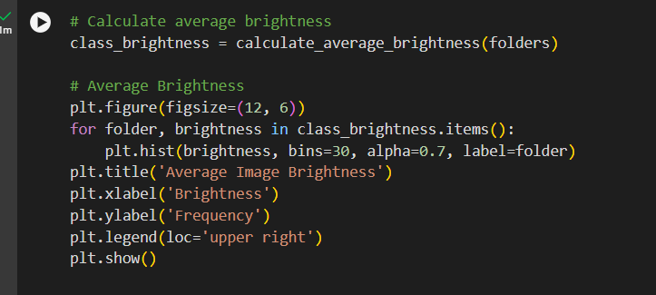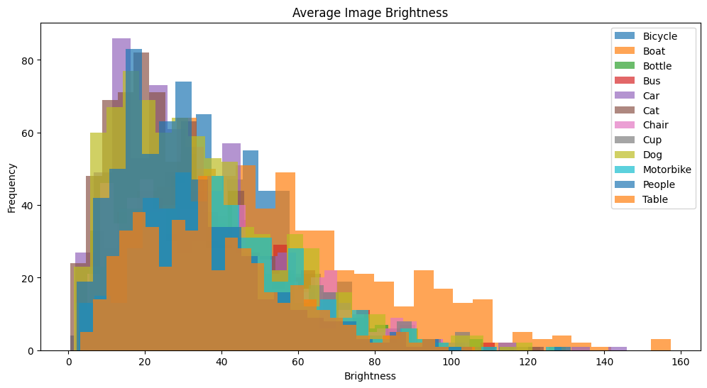

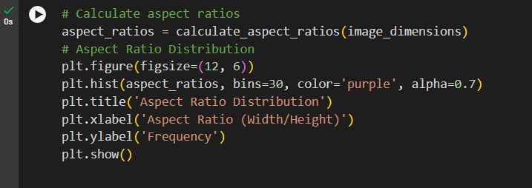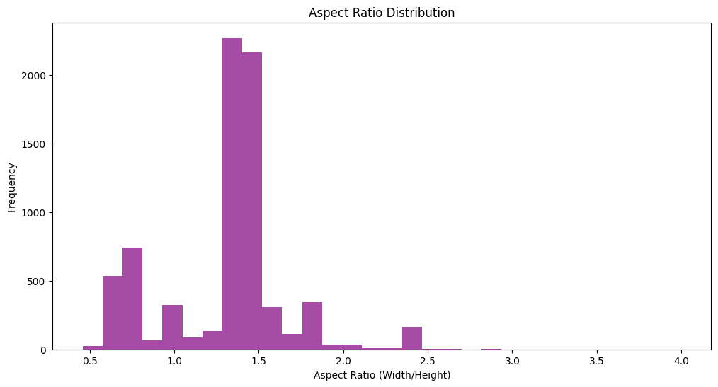

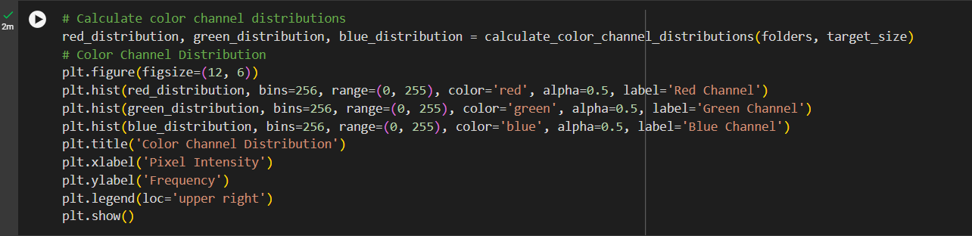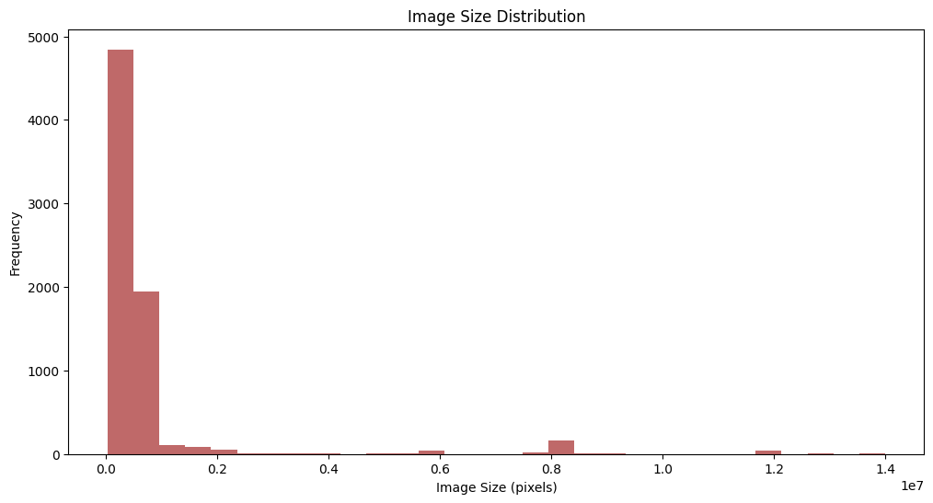

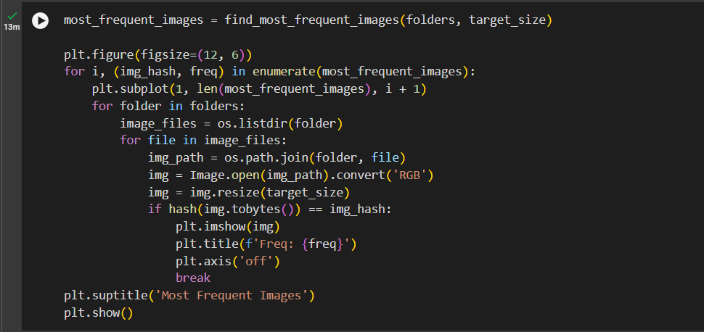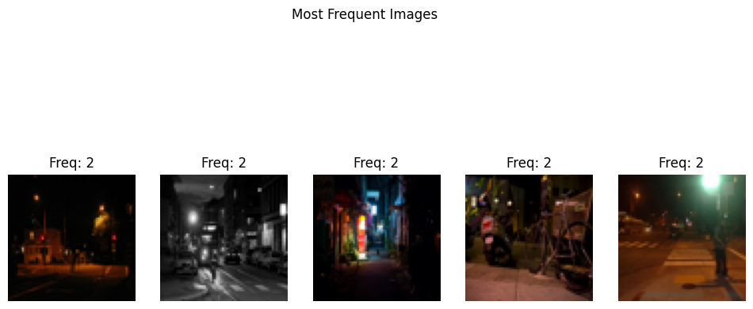

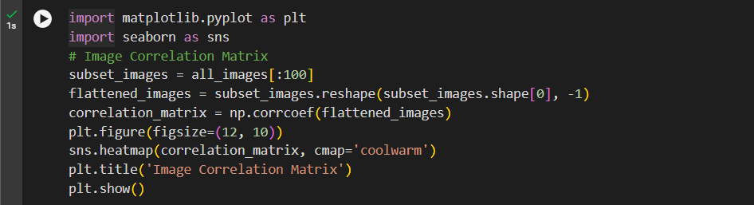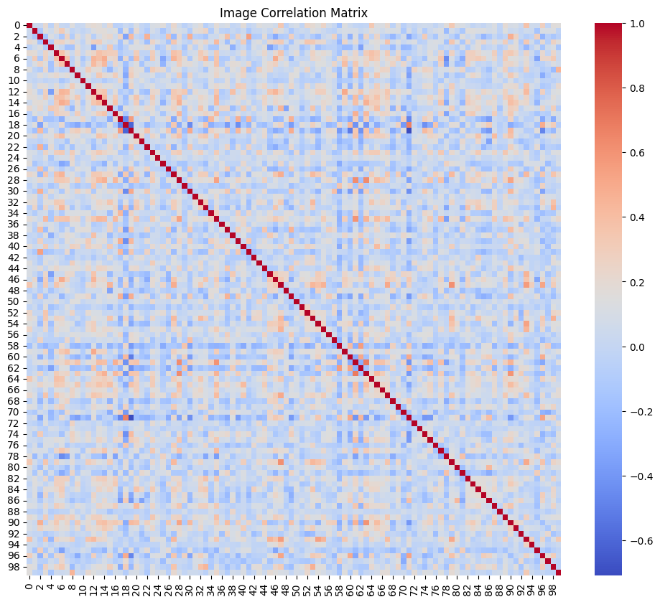

**Activity 2: Computer Vision Techniques for Image Enhancement**

**Key Techniques for Image Enhancement:**

* Histogram Equalization
* Gamma Correction
* Filtering Techniques
* Image Transformation

**Integrating EDA with Computer Vision:**

* The insights gained from EDA inform the selection and tuning of computer vision techniques. For instance, if EDA reveals a consistent lack of contrast in images, histogram equalisation may be prioritised. Conversely, if noise is identified as a major issue, smoothing filters or noise reduction algorithms would be emphasised.

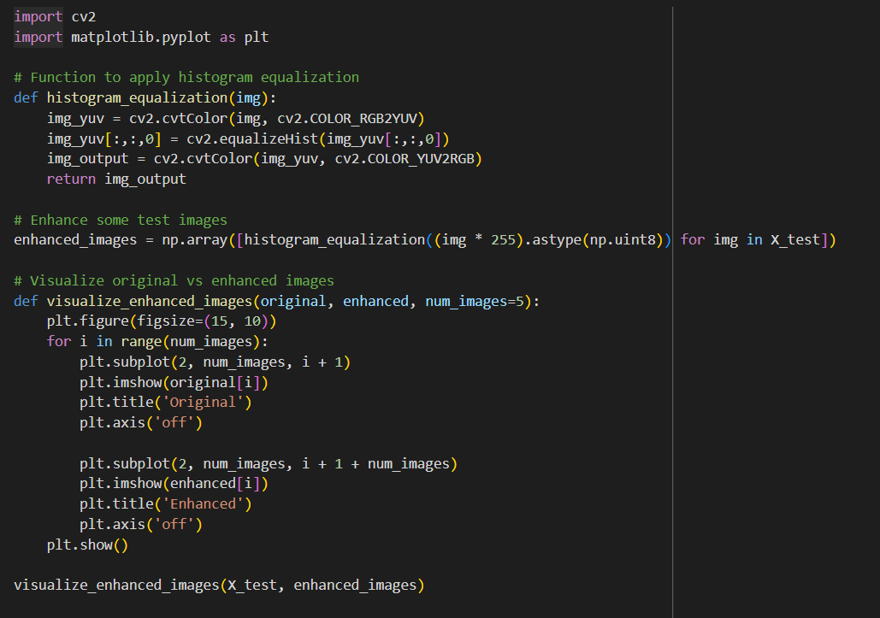

**Final Output:**

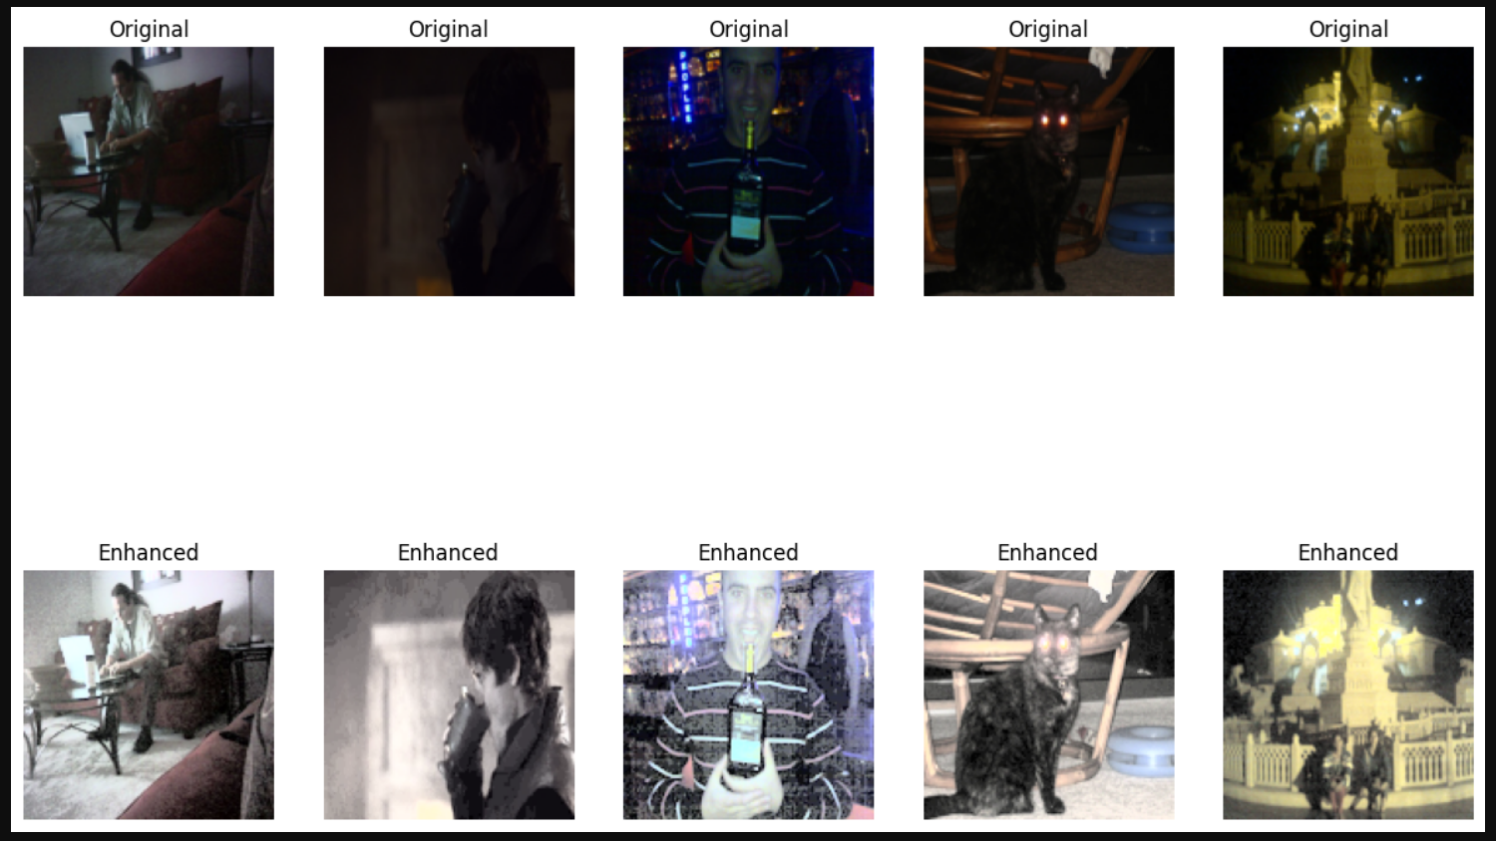

**Conclusion**

The project aimed to improve dark images using Exploratory Data Analysis (EDA) and computer vision techniques. The researchers used histograms and inspections to understand the dataset, revealing darkness, contrast issues, and variations in image quality. They used basic techniques like histogram equalisation and gamma correction to enhance visibility and contrast. The project also highlighted challenges, such as noise amplification in overly dark images. Future work could focus on noise reduction techniques or machine learning-based approaches for automated image enhancement. Experimenting with deep learning models like GANs could offer more advanced solutions for enhancing images with complex degradation patterns. The project's success demonstrates how EDA and computer vision techniques can significantly enhance image quality, particularly in low-light conditions.